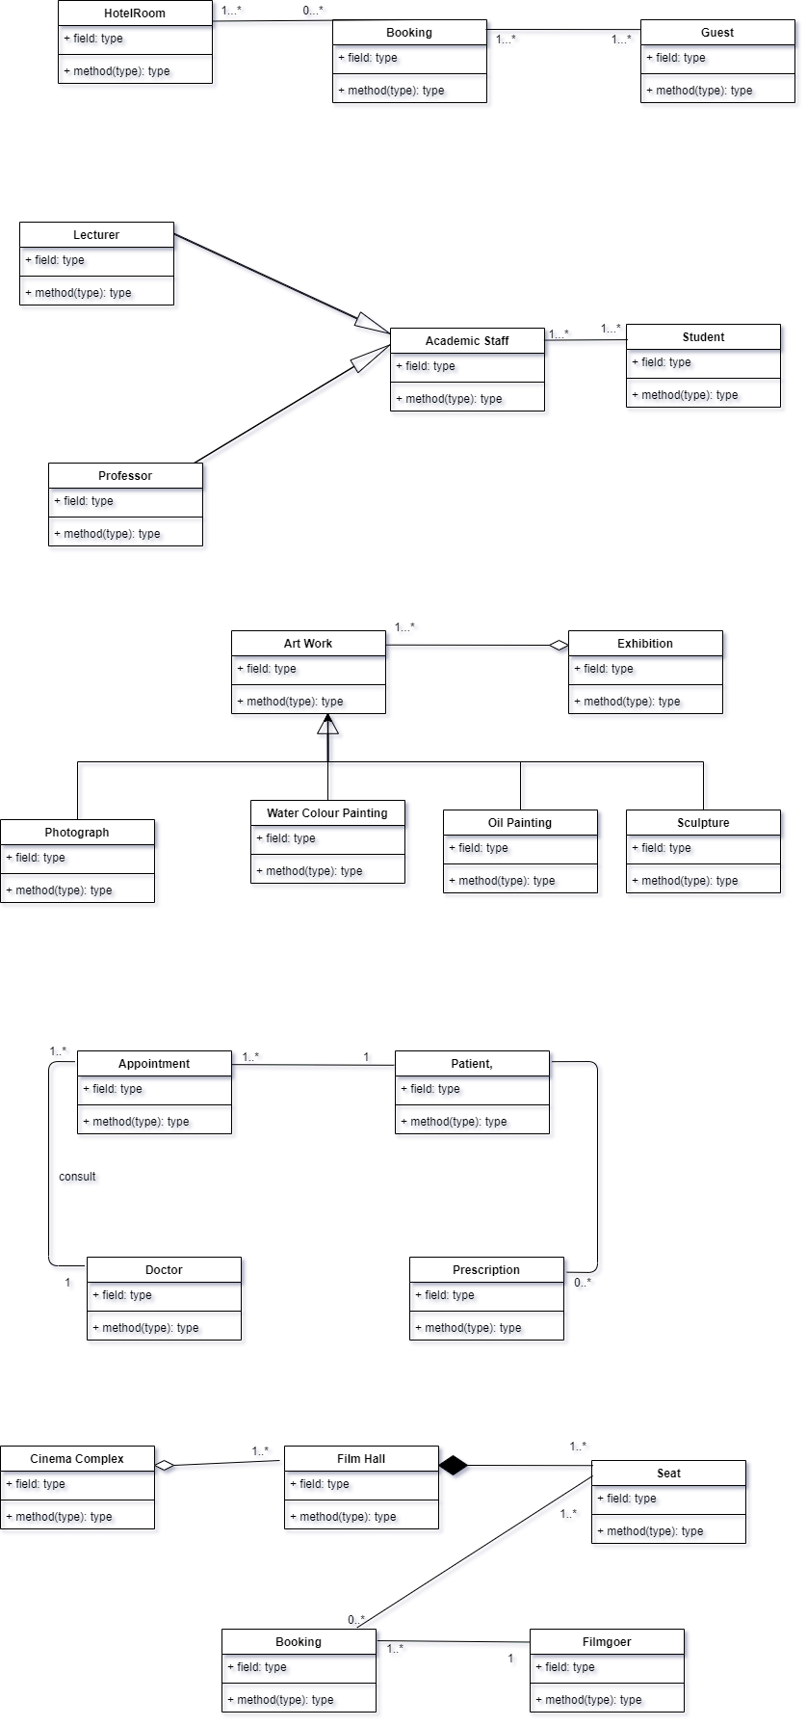

**02**

**01**

**03**

**05**

**04**